*Yong Son*

*Nov 29, 2020*

*IT FDN 110 A Au20: Foundations of Programming: Python*

*Assignment 07*

gitHub link: <https://github.com/yms7/ITFnd100-Mod07/blob/main/docs/index.md>

**save data using Binary format and utilize excepetion functions**

Introduction

In week 07, we learned how to save data into binary format using picking. Last few weeks, we learned how to save data into plain text format. And this week, we learned different technic called pickling. Pickle is one of the python module used to serializing and de-serializing a Python object structure. Structure error handling using built-in class called Exception is another topic that we learned this week. Lastly, we developed Github webpage based on the worked that we did last week and post all our week 07 work on Github webpage.

Pickling: Key notes

Picking is the process to convert the data into binary format. According to our lecture note, storing data in a binary format can obscure the file’s content and may reduce the file’s size.

Python comes with prebuilt module called “pickle”. Programmer can simply import “pickle” module to dump data into binary format and also load and convert binary data back to python. (Figure 7-1)

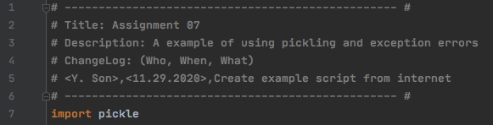

***Figure 7-1: import pickle***

Advantages of using Pickle Module:

1. Recursive objects (objects containing references to themselves): Pickle keeps track of the objects it has already serialized; so later references to the same object won’t be serialized again. (The marshal module breaks for this.)
2. Object sharing (references to the same object in different places): This is similar to self- referencing objects; pickle stores the object once, and ensures that all other references point to the master copy. Shared objects remain shared, which can be very important for mutable objects.
3. User-defined classes and their instances: Marshal does not support these at all, but pickle can save and restore class instances transparently. The class definition must be importable and live in the same module as when the object was stored (Understanding Python Pickling with example, <https://www.geeksforgeeks.org/understanding-python-pickling-example/> 2020) (External site)

Few important points about python pickle module are:

1. The pickle protocol is specific to Python. It’s not guaranteed to be cross-language compatible. This means you most likely can’t transfer the information to make it useful in other programming languages.
2. There is also no guarantee of compatibility between different versions of Python because not every Python data structure can be serialized by the module.
3. The latest version of the pickle protocol is used by default unless you manually change it.
4. Last but not least, the pickle module is not secure against erroneous or maliciously constructed data according to the documentation (Important Notes on Python Pickle, <https://www.journaldev.com/15638/python-pickle-example/> 2020) (External site).

Assignment 07 used the example code sample from (Python Pickle Example, <https://www.journaldev.com/15638/python-pickle-example> 2020) (External site). JournalDev website shares a simple but straightforward process of using Pickle dump and load command in Python script.

Example script simply ask for input of how many data user wants to input and take each input using for loop. All the user input will be save into list called data. Dump command will save all data into a file called “important”. Important file will saved as binary format into a hard drive. Load command will read the binary information saved in “important” file and load it back to python.

This script can be way more complicated if we want to create a table that saved all the information saved in multiple lists. Also input and output options can be more complicated if we want to provide multiple input options to the user. However, for the purpose of the assignment 07, any complicated steps were omitted.

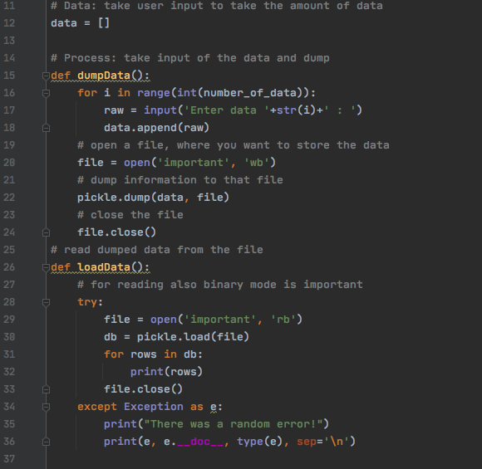

***Figure 7-2: pickling: Data & Process***

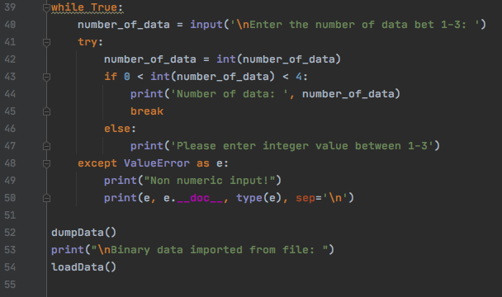

***Figure 7-3: pickling: Presentation***

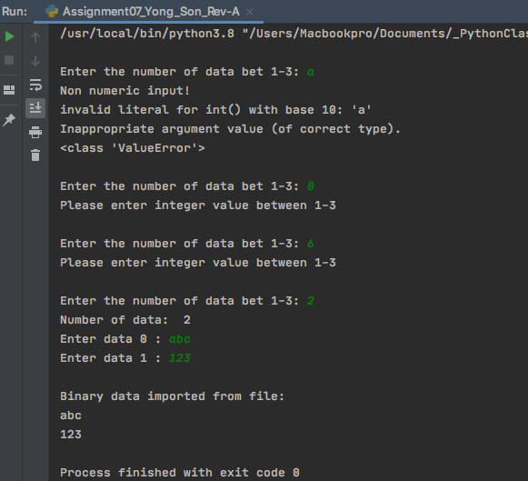

***Figure 7-4: Exception Errors***

Errors and Exceptions:

In Python, there’s built in class that contains information about a common errors.

These built in expression is called Exception. Exception is different from syntax error. Syntax error occurs when the program detects an incorrect statement but an Exception error happens only if certain condition occurs such as when the number is divided by zero or input value is non-numeric. Python’s Exception statement automatically detects and creates an Exception object when the error occurs.

Try and except clause will be the most common way to use Exception statement. In this assignment, I used try and except clause under while loop. My script will run as long as user’s input value stays in certain range and for any other input values, Exception statement will occur and show the error message (Figure 7-3 & 7-4), (8.3. Handling Exceptions, <https://docs.python.org/3/tutorial/errors.html> 2020) (External website).

Other resources were also used as reference. Below are the links that I used for reference information on Exception classes:

How to use try except statement in python to handle non-numeric inputs,

<https://stackoverflow.com/questions/46380181/how-to-use-try-except-statement-in-python-to-handle-non-numeric-inputs> 2020, external website.

List of Built in exceptions, <https://docs.python.org/3/library/exceptions.html#bltin-exceptions> 2020, external website.

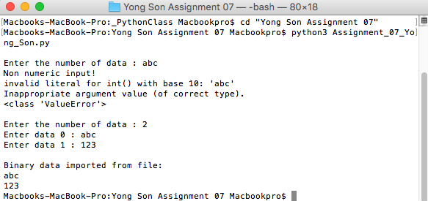

***Figure 7-5: Terminal Result: Assignment 07 using Pickle and Exception Errors***

Summary

In assignment 07, I used the examples from multiple websites to write a script that uses Pickle module and Exception error classes. This was first time for me to use any built in Python modules and this Pickle module was very easy to use since there are only two commands to remember “dump” and “load”. However, working with binary formatted file was a quite challenging. Mac applications were not binary friendly at all. I had to find different program to open binary file since text file does not support to ready any binary information.

Learning Exception class was interesting but at the same time it was quite of challenging work for me. As a programmer, I had to plan ahead and think of any possible errors that may occur during the operation of my code. Writing Exception code is based on the possible errors that may occur and it was difficult to visualize what type of error may occur during the usage of my program. I used most common Exception error on my script but once I build more experiences in coding I would be able to use multiple exception classes on my script.